President Meric Gertler, CM FRSC FBA FAcSS MCIP
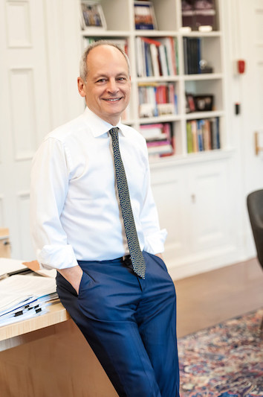
Meric S. Gertler began his term as the 16th President of the University of Toronto on November 1, 2013. Prior to that, he served as Dean of the Faculty of Arts & Science—the largest faculty at the University—from 2008 to 2013, where he championed many important innovations in undergraduate teaching and learning.

He is a Professor of Geography and Planning, and the Goldring Chair in Canadian Studies at the University of Toronto. He is a co-founder of a large research program at U of T’s Munk School of Global Affairs and Public Policy investigating the role of city-regions as sites of innovation and creativity in the global economy. His work engages in comparative analysis of North American and European cities to understand how local social and cultural dynamics create the foundations for economic success and prosperity.

Professor Gertler has served as an advisor to local, regional and national governments in Canada, the United States, Singapore and Europe, as well as to international agencies such as the Organisation for Economic Cooperation and Development (Paris) and the European Union. He has authored or edited nine books, including Manufacturing Culture: The Institutional Geography of Industrial Practice and The New Oxford Handbook of Economic Geography (with Gordon Clark, Maryann Feldman and Dariusz Wójcik). He has held visiting appointments at Oxford, University College London, UCLA, and the University of Oslo.

Professor Gertler is co-chair of the Business-Higher Education Roundtable, a trustee of Toronto’s Hospital for Sick Children, a director of MaRS Discovery District and a member of the Board of Universities Canada. He is chair of the U15 Group of Canadian Research Universities and a founding member of the Corporate Leadership Table convened by BMO Financial Group and United Way of Greater Toronto to promote Inclusive Local Economic Opportunity. He also serves as chairperson of the Academic Committee of the China Institute for Urban Governance, and sits on the Singapore Ministry of Education’s 11th International Academic Advisory Panel and the International Advisory Board of Uppsala University in Sweden. He previously served on the Expert Panel on Business Innovation in Canada for the Council of Canadian Academies, and the Ontario government’s Highly Skilled Workforce Planning and Partnership Table.

A graduate of McMaster University (BA), the University of California, Berkeley (MCP) and Harvard University (PhD), Professor Gertler holds honorary doctorates from Lund University, Sweden, Shanghai Jiao Tong University, China, and Université de Montréal. He is a Fellow of the Royal Society of Canada, the Academy of Social Sciences (UK), the Royal Canadian Geographical Society and a Corresponding Fellow of the British Academy. He has received the Award for Scholarly Distinction in Geography from the Canadian Association of Geographers, the Distinguished Alumni Award from the College of Environmental Design at the University of California, Berkeley and the Distinguished Scholarship Honor from the Association of American Geographers. In December 2015, Professor Gertler was appointed to the Order of Canada.

